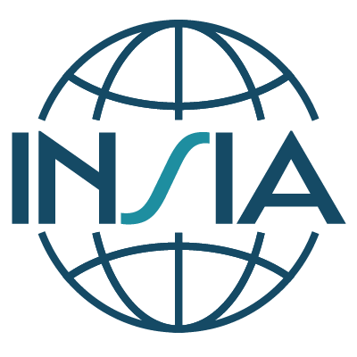
INSIA Board Elections 2025
Candidate Form
To be completed by candidate
Candidate’s name:
Title:
Agency Name:
Candidate for: | ☐ Chair  ☐ Vice-Chair  ☐ Director
Have you previously held a position on the INSIA Board? | Check one:  ☐ Yes  ☐ No  If yes, list the position(s) have you held and the term(s), e.g., Director 2019 – 2021:
Briefly describe your experience with and/or knowledge of INSIA | (max 200 words)
Candidate’s vision for INSIA: | Please provide a vision statement (max 300 words):
Curriculum Vitae
(Enter here or send as an attachment)

Understanding of Expectations
By signing below, I indicate that I have read and accept the INSIA Bylaws and Governance Regulations and that if I am successfully elected to the Board there is the expectation that I will:
- Represent the views and interests of INSIA members, and develop and advance initiatives that benefit INSIA members.
- Regularly participate in Board meetings throughout the year. In general, there are annually 10 Board meetings of 2-hour duration by web conference.
- Participate in activities of the Board by leading and/or assisting in the implementation of the objectives of INSIA.
Declaration of Conflicts of Interest
I hereby declare that I have no commercial or other vested interests in matters that would be against the aim of INSIA or otherwise conflicting to its aim.
Signature |  | Place, Date
Send completed form by 19 March 2025 at 23:59 CET to:
Nick Baillie, Chair, INSIA Nominations Committee
Email: nick.baillie@nice.org.uk
With cc to the INSIA Secretariat (insia@sbu.se)

