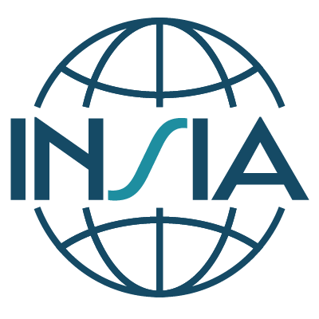

INSIA Board Elections 2025
Agency Authorization Form for Candidate Nomination
To be completed by the Director/Head of the HTA Agency where the Candidate is employed.
If the Candidate is also the Director/Head of the Agency, this form is not required.

Your Agency name:
Your name:
Your title / position:

Dear Nominations Committee,

I acknowledge the candidacy of [INSERT CANDIDATE NAME], a staff member of my agency, for the position of on the INSIA Board of Directors.

I understand that if this person is successfully elected to the Board, there is the expectation that they will:
- Represent the views and interests of INSIA members and develop and advance initiatives that benefit INSIA members.
- Regularly participate in Board meetings throughout the year. In general, there are annually 10 Board meetings of 2-hour duration by web conference each year.
- Participate in activities of the Board by leading and/or assisting in the implementation of the strategic objectives of INSIA. This would include serving in at least one of the following roles: Executive Committee member, Treasurer, Chair of Board Committee or Task Group.

Authorization:
Send completed form by 19 March 2025 at 23:59 CET to:
Nick Baillie, Chair, INSIA Nominations Committee
Email: nick.baillie@nice.org.uk
With cc to the INSIA Secretariat (insia@sbu.se)

Signature |  | Place, Date

